|  |  |
| --- | --- |
| **Assignment Case** |  |
| COMP6048  Data Structures |
| **Computer Science** | **E213-COMP6048-SO07-01** |
| ***Valid on*** *Even Semester Year 2021/2022* | **Revision 00** |

1. Seluruh mahasiswa tidak diperkenankan untuk:

*All students are not allowed to:*

* + - Berdiskusi dan/atau bekerja sama dengan mahasiswa lainnya

*Discuss and/or work together with other student participants*

* + - Melihat sebagian atau seluruh jawaban mahasiswa lain

*Seeing a part or the whole answer from another student*

* + - Membuka dan menyalin dari **BUKU** atau **CATATAN**, **VIDEO** dari pengajar (recording kelas, VBL, Youtube, dsb) dan **REFERENSI** lainnya

*Open and copy from any resources such as notes, videos (class recording, VBL, Youtube, etc) and other references*

* + - Membuka dan menyalin jawaban dari internet (google, stackoverflow, dsb)

*Open and copy answer from the internet (google, stackoverflow, etc)*

* + - Mengerjakan soal yang tidak sesuai dengan tema yang ada di soal,

*Working with another theme which is not in accordance with the existing theme in the matter of the case,*

* + - Melakukan tindakan kecurangan lainnya,

*Committing other dishonest actions,*

* + - Secara sengaja maupun tidak sengaja melakukan segala tindakan kelalaian yang menyebabkan hasil karyanya berhasil dicontek oleh orang lain / kelompok lain.

*Accidentally or intentionally conduct any failure action that cause the results of the project was copied by someone else / other groups.*

1. Jika mahasiswa terbukti melakukan tindakan seperti yang dijelaskan butir 1 di atas, maka **nilai mahasiswa** yang melakukan kecurangan (menyontek maupun dicontek) akan di – **NOL** – kan.

*If the student is proved to the actions described in point 1 above, the score of the student which committed dishonest acts (cheating or being cheated) will be “Zero”*

1. Perhatikan jadwal pengumpulan jawaban, segala jenis pengumpulan jawaban di luar jadwal tidak dilayani.

*Pay attention to the submission schedule, all kinds of submission outside the schedule will not be accepted*

1. Bila Anda tidak membaca peraturan ini, maka Anda dianggap telah membaca dan menyetujuinya

*If you have missed to read these regulations, so you are considered to have read and agreed on it*

1. Persentase penilaiaan untuk matakuliah ini adalah sebagai berikut:

*Marking percentage for this subject is described as follows:*

|  |  |
| --- | --- |
| **Tugas Mandiri**  *Assignment* | **UAP**  *Final Exam* |
| 40% | 60% |

1. Software yang digunakan pada matakuliah ini adalah sebagai berikut:

*Software will be used in this subject are described as follows:*

|  |
| --- |
| **Software**  *Software* |
| Dev-C++ 5.11 |

## Ekstensi file yang harus disertakan dalam pengumpulan tugas mandiri, dan uap untuk matakuliah ini adalah sebagai berikut:

*File extensions should be included in assignment and final exam collection for this subject are described as follows:*

|  |  |
| --- | --- |
| **Tugas Mandiri**  *Assignment* | **UAP**  *Final Exam* |
| CPP | CPP |

## Soal

*Case*

**Mini SO**

**Mini SO** is a well-known mini market in Jakarta. **Mini SO** sells various product from health product food, and digital product. To increase the efficiency in **Mini SO**, you as a programmer in **Mini SO** are asked to create a program that can maintain customer order data using **C language** and **Chaining Hash Table** data structure. The program that will be created must be following the below requirements.

* The program will have **3 menu items** and **show** **all** of **products**:

1. Add New Product
2. Delete Product
3. Exit

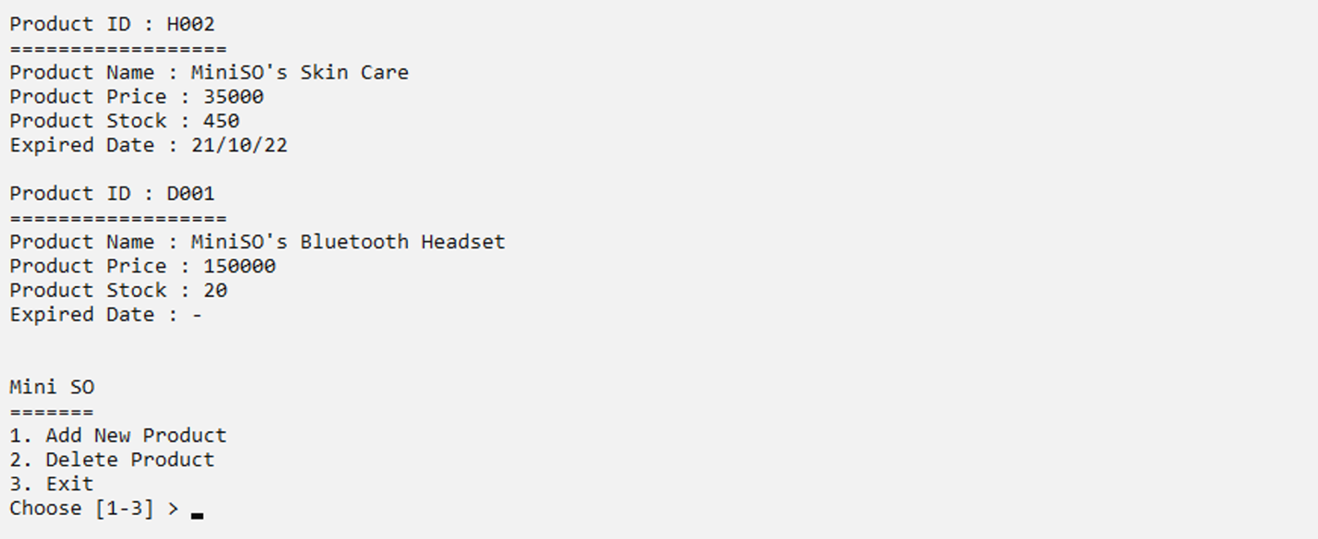

Figure 1. Main Menu with Products

* If there are **no product yet** or **the list is empty**, then the program **should show no product message**.

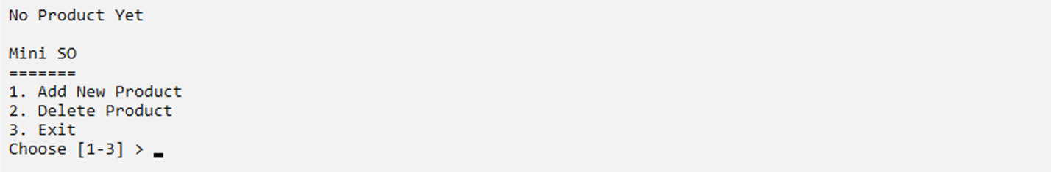

Figure 2. Main Menu with No Product

* If the user choose **menu 1** (**Add New Product**), then:

1. The program will ask user to input the **product name** and **validate** that the **name** must **more than 5** **characters**.
2. The program will ask user to input the **product price** and **validate** that the **price** must be **between 1 to 150000** (**inclusive**).
3. The program will ask user to input the **product stock** and **validate** that the **stock** must **more than 0**.
4. The program will ask user to input the **product category** and validate that the **category** must be **“Health”, “Food” or “Digital” (case sensitive).**

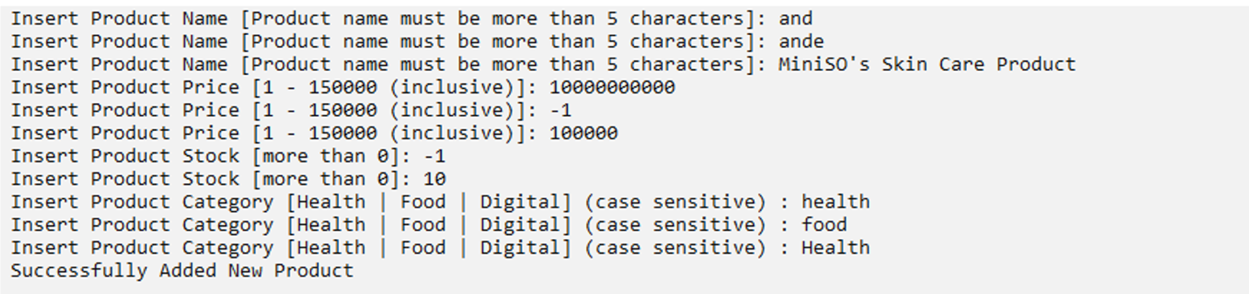

Figure 3. Input Validation

1. The program will generate **expired date** if the **product category** does not equal to “Digital”. The **expired date** must **follow** the **format below**:

**Expired Date = Day/Month/Year**

Day : Random (1-30)

Month : Random (1-12)

Year : Random (20-25)

Figure 4. Generate Expired Date

1. The program will **generate the Product Id** for the inputted product data. The Product Id must **follow** the **format below**:

**YXXX**

XXX : the last 3 digit of the last product id added by 1

**Category**

Health : Y = “H”

Food : Y = “F”

Digital : Y = “D”

**Example**

The last product id is **H002**

Then the new generated product id with **Food** **category** is **F003**

Figure 5. Product Id Format

1. The program will **store new product data** to the **next item** of the **last item** of **chaining hash table** with **size** **100** using the following **hash function**.

**Key = (X[0]* (X[3] + X[1] – X[2])) % Y;**

Key : the hash table index that will store the data

X : ID of the Product that will be stored

Y : size of the hash table (100)

**Example:**

Product ID : F001

Size : 100

Key : (70 * (49 + 48 - 48)) % 100

: 30

Then the product data will store at index 30 of hash table

*P.s for each character on X is based on ASCII*

Figure 6. Hash Function

* If the user choose **menu 2** (**Delete Product**), then:

1. The program will **show all the product list**. If there are **no product yet** or **the list is** **empty**, then the program **should show no product message** and **redirect** user back to menu page.



Figure 7. No Product Yet to Delete

1. Otherwise, the program will ask user to input the **product id to delete** and **validate** that **product ID must start with “H”, “F”, “D” (case sensitive)**.

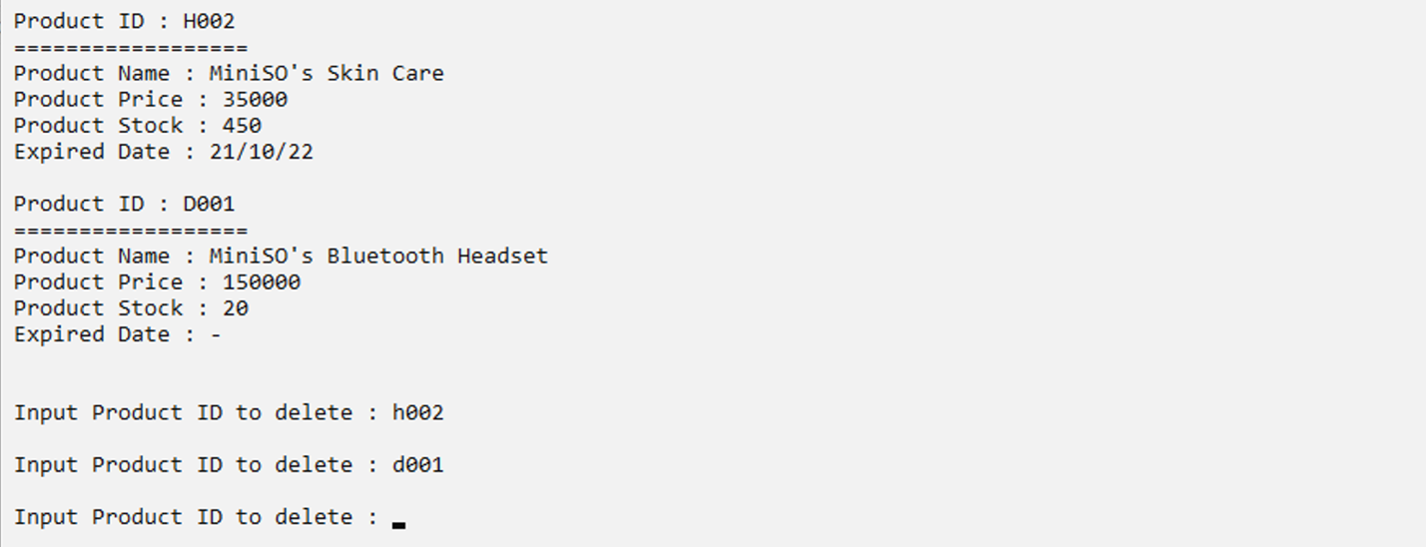

Figure 8. Validate Input Product Id

1. The program will **search** for the **specified product (case sensitive)**.

* If the **product id** is **not found** the program will **show** the **data not found** message and user willbe **redirect** backtomenupage.

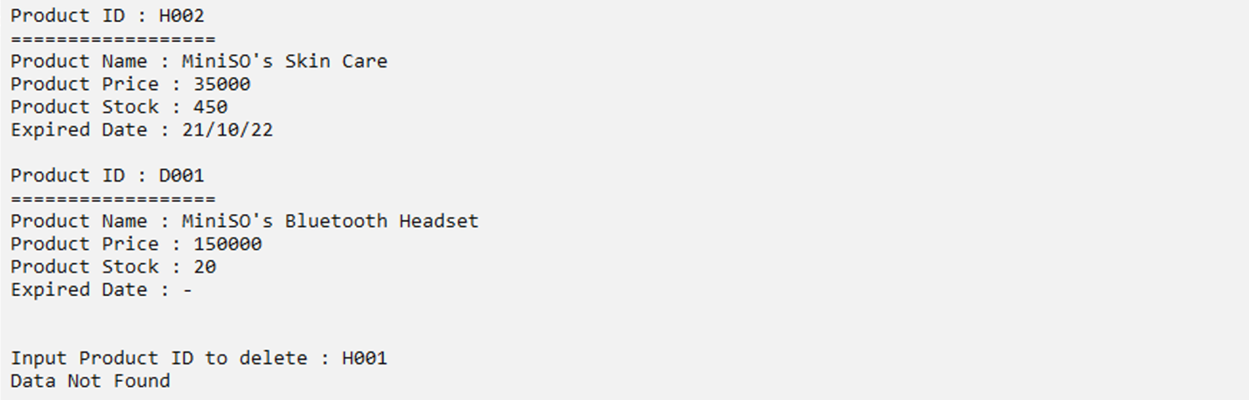

Figure 9. Data Not Found Message

* If the **product id exists**, then:
  + **Confirm** about **removing product data** and **validate** input must be **Y/ N (case insensitive)**

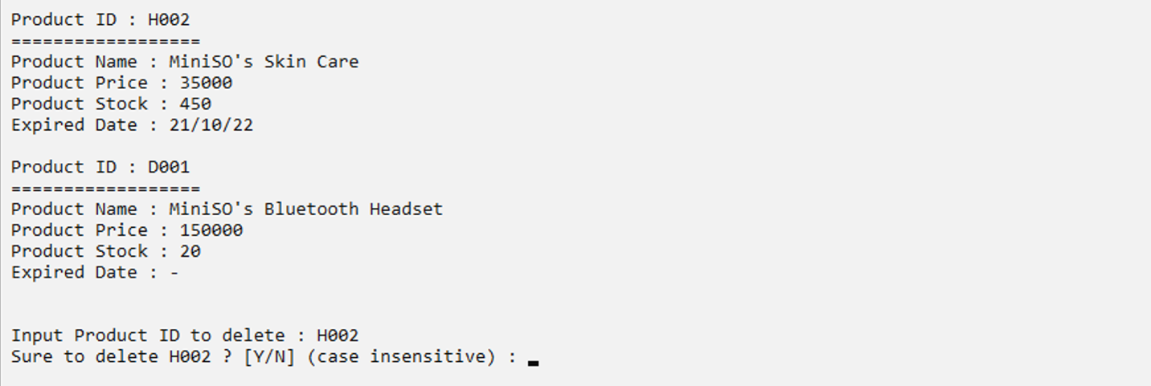

Figure 10. Remove Product Validation

* + The program will **remove** the **product data** from the **chaining hash table** if user **input** **Y** or **y** and **show success message.** Otherwise, will be **redirect** **back** to menu page.

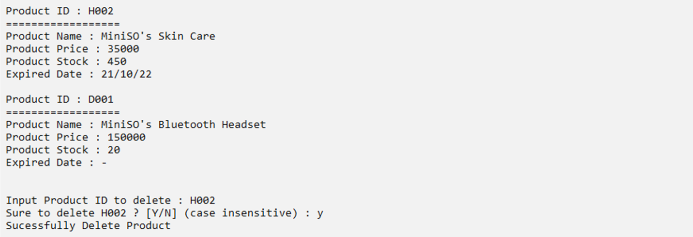

Figure 11. Successfully delete product message

* If the user choose **menu 3** (**Exit**), then the program will **exit**.



Figure 12. Exit message

**Please run the EXE file to get more detail about the application.**

Here are the rules that you must follow to create your project:

1. Use appropriate software for this subject based on **Sistem Praktikum** that can be downloaded from Binusmaya
2. Use the techniques taught during practicum
3. Collect appropriate files for this subject based on **Sistem Praktikum** that can be downloaded from Binusmaya
4. Include the other files that can support your project, such as:
   * All files in your project
   * Other files (image, audio, video, etc.) used in your project
   * *.DOC file (documentation of your project) that contains the reference links of additional files (image, audio, video, etc.) used in your project